LAB 1 (Octave)

Part 1:

1-

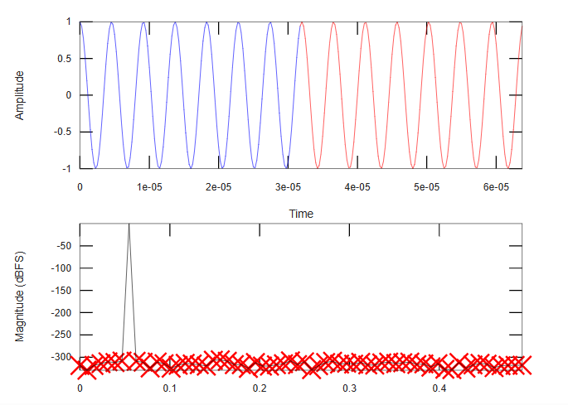

1. From plot , the power of the peak signal = 0 dBFS
2. As there is no leakage we can see that almost all power is at one bin (main lope ) and other bins are negligible
3. From plot , noise floor is -310 dBFS
4. There is no leakage but noise floor can be because of quantization error if signal is digitalized or mathematical issues due to FFT

2-

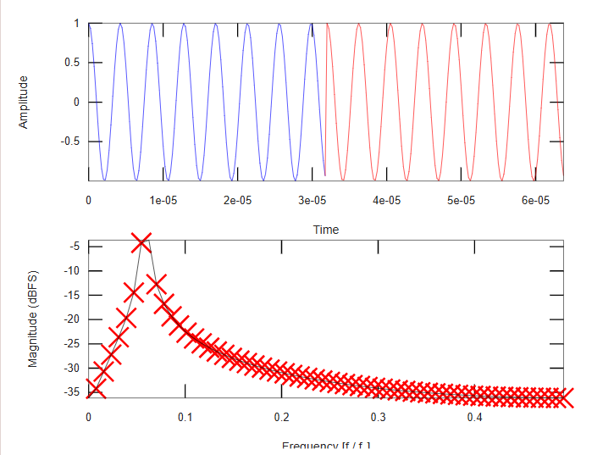

1. From plot , the power of the peak signal = -4 dBFS (nearly)
2. As there is now leakage in the spectral power we can see that there is spread in the power concentration over many bins and side lopes appear due to sinc response (no. of bins nearly 5-7)
3. From plot , noise floor is nearly -35 dBFS
4. There is spectral leakage that causes errors due to the abrupt change in the sin input as we see in the first plot .

It also can be because of quantization error if signal is digitalized or mathematical issues due to FFT.

**3- Blackman harris**

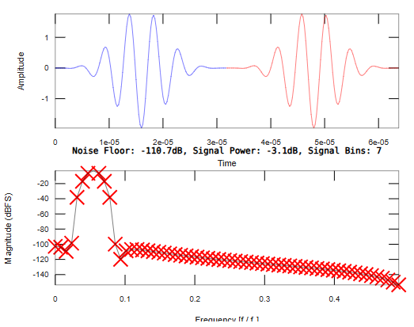

a-From plot , the power of the peak signal = -3 dBFS

b-No of occupied bins nearly = 6-8

c-From plot , noise floor is -110 dBFS

d- The primary source of this noise floor is finite precision effects and spectral leakage due to the windowing function itself.

There is window side lopes that is not totally eliminated and corresponds to raising noise

Quantization noise and Round-off Errors in FFT Computation

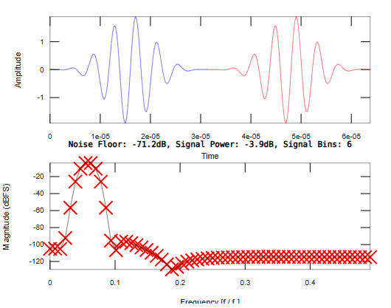

a-From plot , the power of the peak signal = -4 dBFS

b-No of occupied bins nearly = 6-8

c-From plot , noise floor is **-105** dBFS

d- number of cycles is not an integer so additional error sources come into play like spectral leakage due to discontinuities at the edges of the sampled data.

Even though the Blackman-Harris window is designed to suppress leakage by reducing side lobes, it cannot eliminate it completely.so they add noise to the noise floor aswell

**4-Hanning :**

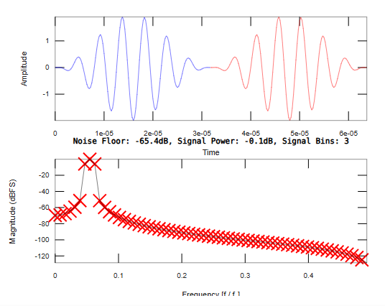

a-From plot , the power of the peak signal = 0 dBFS

b-No of occupied bins nearly = 3-5

c-Frpm plot , noise floor is -65 dBFS

**d-** The Hanning window reduces spectral leakage compared to a rectangular window, but it spreads energy across neighboring bins.

These window side lopes can cause raising in the noise floor.

Quantization noise and Round-off Errors in FFT Computation

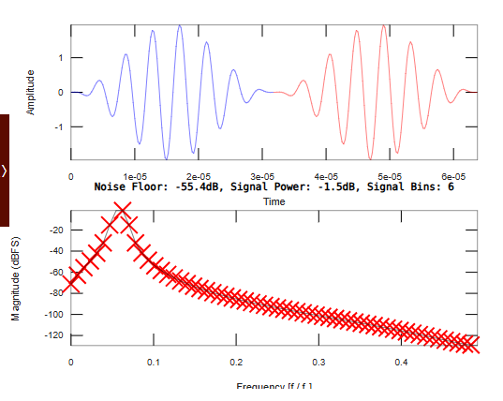

a-From plot , the power of the peak signal = -1.5 dBFS

b-No of occupied bins nearly = 5-7

c-Frpm plot , noise floor is -60 dBFS

**d-**

If the number of cycles is not an integer, the noise floor is raised due to additional factors like Spectral Leakage (Main Cause of Noise Floor Increase) as The signal is not periodic within the FFT window, leading to discontinuities at the edges.

This causes energy to spread across the entire spectrum.

The Hanning window reduces but does not eliminate leakage, leading to a higher noise floor compared to the integer-cycle case.

5-

|  |  |  |
| --- | --- | --- |
| WINDOW | Blackman Harris | Hanning |
| Case 1(integer Ncyc) | Peak signal= -3dB  No. of bins = 6-8  Noise floor =-110 dB | Peak signal= 0dB  No. of bins = 3-5  Noise floor =-65 dB |
| Case 2(non integer Ncyc) | Peak signal= -4dB  No. of bins = 6-8  Noise floor =-104 dB | Peak signal= -1.5dB  No. of bins = 5-7  Noise floor =-60 dB |
| Comment | 1-Better side lobe suppression However, broader main lobe, which reduces frequency resolution slightly  2- Best for reducing leakage due to extremely low side lobes and low noise floor  3- spectral broadening can be an issue. | 1-Has a narrower main lobe, so it better preserves resolution.  2- Helps reduce spectral leakage, but not as much as Blackman-Harris.  3- Spectral leakage remains noticeable, but resolution is still better than Blackman-Harris. |

**Part 2: quantization :**

**1-**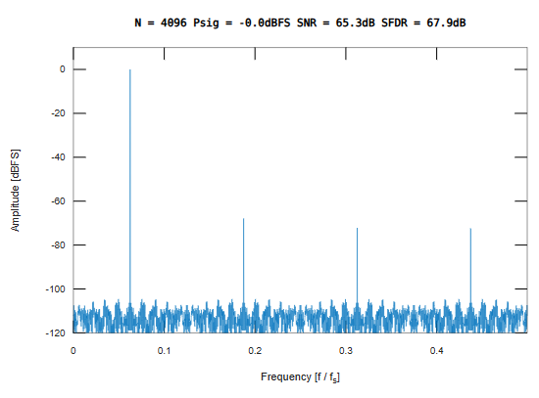

1. There is distortion components because of the integer correlation between number of cycles and number of samples (both power of 2 and not mutually prime ).

**SNR (analytically):**

SNR= 6.02*B+1.76dB

=(6.02*10) +1.76 =61.96 dB

From plot SNR = 65 db

There is about 3dB deviation between the two values

1. Noise floor = SNR + FFT processing gain

FFT processing gain= 10 log(M/2) = 10log(2048)=33.11 dB

Noise floor = 61.96+33.11= 95.073 dB

**From plot :** Noise floor= 104 dB

There is nearly 9dB deviation in the calculations from analytical and plot

1. SFDR= 67.9 dB

This is because of the bad choise of Ncyc as it is even number the ratio with N is integer so there is large distortion components appears in the frequency domain

**2-** 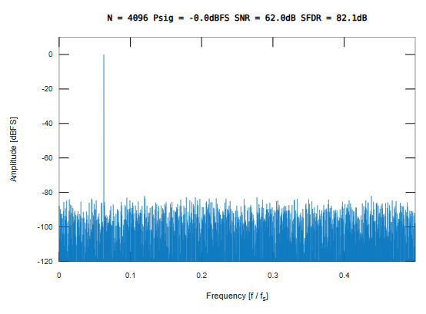

1. There is no distortion components because now there is no correlation between Ncyc and N so the ration between them is not integer and Ncyc is odd number
2. **SNR (analytically):**

SNR= 6.02*B+1.76dB

=(6.02*10) +1.76 =61.96 dB

From plot SNR = 62 db

The two values are the same now

1. Noise floor = SNR + FFT processing gain

FFT processing gain= 10 log(M/2) = 10log(2048)=33.11 dB

Noise floor = 61.96+33.11= 95.073 dB

**From plot :** Noise floor= 90 dB

The deviation between the values decreased

1. SFDR= 82.1 dB

This is because of the good choise of Ncyc as it is odd number the ratio with N isn’t integer so there is no distortion noticed and SFDR improved

**3-**

|  |  |
| --- | --- |
| **Case 1** | **Case 2** |
| SFDR= 67.9 dB | SFDR= 82.1 dB |
| **Comment :** there is distortion components that affects the SFDR due to the bad choice of Ncyc as even number (power of 2) and correlated with N | **Comment :** there is no distortion components that affects the SFDR due to the good choice of Ncyc as odd number (not power of 2) and not correlated with N so SFDR improved |